Git Hands-on Lab Report
Objective
Configure Git, integrate Notepad++ as the default editor, initialize a Git repository, create and commit a file, and verify repository status.

Prerequisites
- Git for Windows installed
- GitHub account (optional for push)
- Notepad++ installed

Commands and Outputs
Step | Command | Expected Result
Check Git version | git --version | Displays installed Git version.
Configure username | git config --global user.name "Pravallika" | Sets Git username.
Configure email | git config --global user.email "pravallikaruth007@gmail.com" | Sets Git email.
Verify configuration | git config --global --list | Shows username, email and core.editor.
Configure Notepad++ editor | git config --global core.editor "notepad++.exe -multiInst -nosession" | Sets Notepad++ as default Git editor.
Open Git config | git config --global -e | Opens .gitconfig in Notepad++.
Create project folder | mkdir GitDemo | Creates GitDemo directory.
Enter project | cd GitDemo | Moves into project folder.
Initialize repository | git init | Creates .git repository.
List files | ls -al | Shows hidden .git folder.
Create file | echo "Welcome to the version control" > welcome.txt | Creates welcome.txt.
View file | cat welcome.txt | Displays file content.
Check status | git status | Shows welcome.txt as untracked.
Stage file | git add welcome.txt | Adds file to staging area.
Verify staging | git status | Shows 'Changes to be committed'.
Commit | git commit | Enter commit message: First Commit
Final verification | git status | Shows 'nothing to commit, working tree clean'.

SCREENSHOTS OF COMMANDS
- Git Version
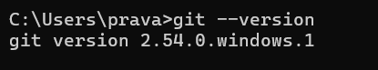
- Git Configuration
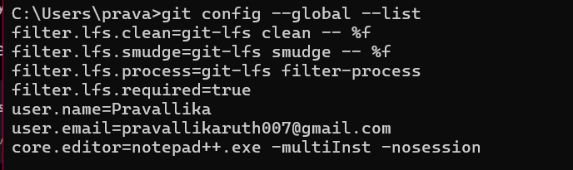
- Notepad++ as Default Editor
git config --global -e
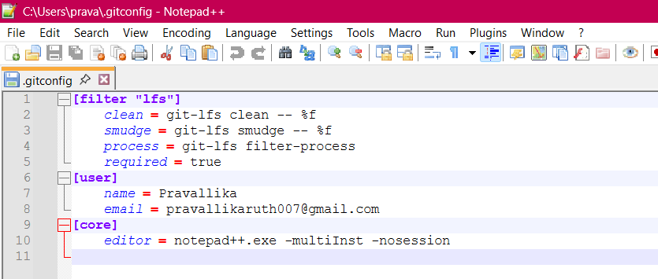
- Create Repository
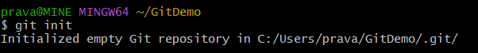
- Verify .git Folder
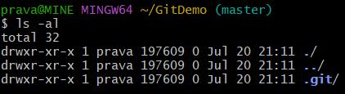

- Create File
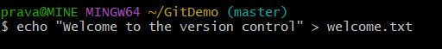
- Verify File Content
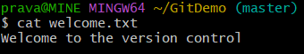
- Git Status (Before Adding)
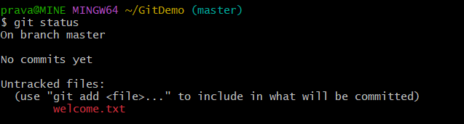
- Add File
- Git Status (After Adding)
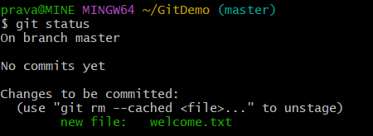
- Commit Message in Notepad++
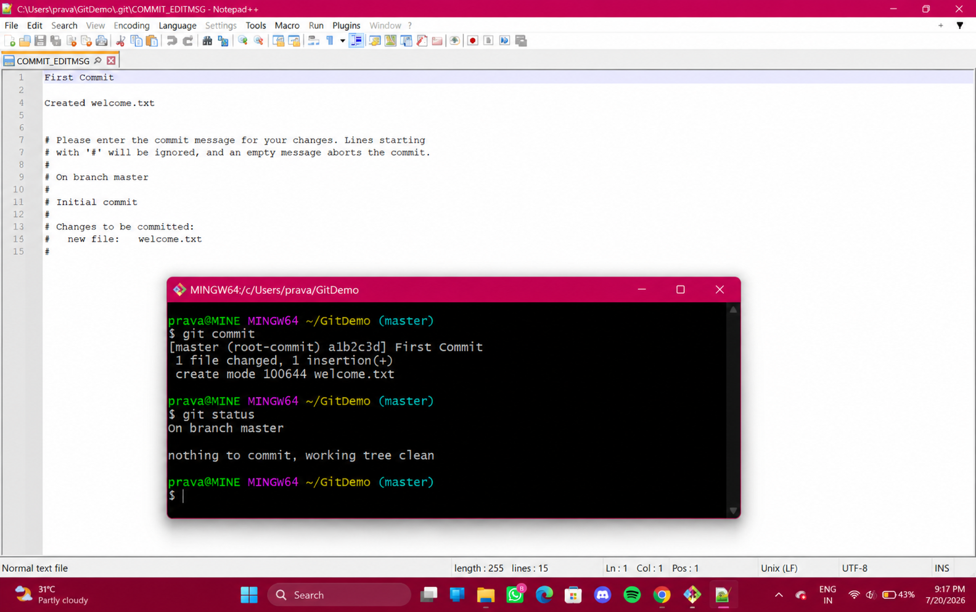
- Final Git Status
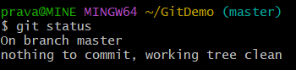

Final Output
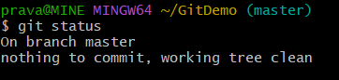

Conclusion
Git was configured successfully, Notepad++ was integrated as the default editor, a local repository was created, welcome.txt was committed successfully, and the repository status was verified as clean.

